Our Collection
We proudly offer a wide range of fragrances including:
- Luxury Men’s Perfumes
- Elegant Women’s Perfumes
- Unisex Signature Scents
- Exclusive Imported Collections
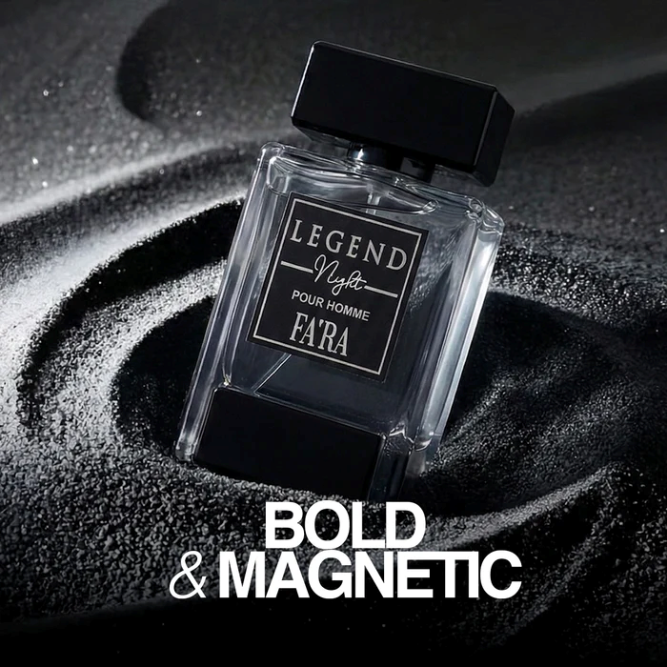
Each fragrance is carefully selected to ensure superior quality, long-lasting performance, and timeless appeal.
Why Choose Paarees Perfumes
- 100% Authentic & Branded Products
- Affordable Luxury Pricing
- Long-Lasting Premium Fragrances
- Customer Satisfaction Focused
- Carefully Curated International Brands
Our Promise
We are committed to delivering excellence in every bottle. Whether you seek freshness for daily wear or bold sophistication for special occasions, Paarees Perfumes helps you define your unique style with confidence.
Paarees Perfumes — Discover the Power of Fragrance.

